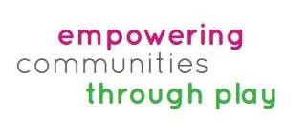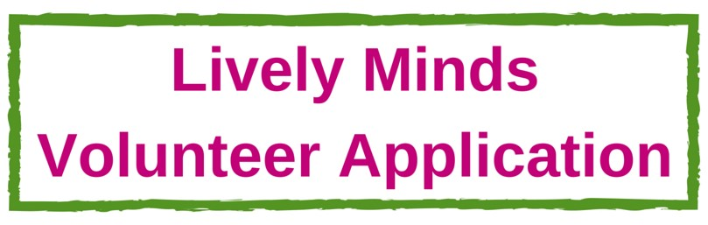

Thank you for your interest in volunteering with Lively Minds. Please return this application form by email to info@livelyminds.org

You will be contacted by email within 5 working days with the status of your application. If shortlisted you’ll need to be available for an informal interview (either at our office in Archway, North London, or over Skype).

Full Name
Gender
Date of Birth
Address
(Permanent)
Address (term-time if student)
University/Workplace (if applicable)
Telephone
Email
How did you hear about Lively Minds?
Do you have any special considerations that we might need know about so that we can make appropriate arrangements in Ghana/Uganda? (e.g.
health related or other)

Please tell us about why you would like to take part in our volunteer programme and what you hope to gain from it (200 words max):

Please write a short personal statement to tell us about yourself and what skills and/or experience you can bring to Lively Minds (300 words max):

What challenges do you think you might face working with communities and children in Ghana/Uganda and how do you think you would deal with them? (200 words):

The Volunteer Scheme takes place in a challenging environment where facilities (including medical) are basic. We recommend that Volunteers are in good physical and mental health. If you have a significant medical condition, please let us know so that we can discuss the implications of volunteering on your health and adjustments that we can make to support you. We will treat any disclosure in strict confidence.

Current Situation
e.g., student, recent graduate, employed
If you are a student or recent graduate - Name of course and university.
If currently employed - Company, type of organisation and role
If applicable - Previous employment- Company, type of organisation and
role. (Only a summary required)
School/College/Uni attended with dates and qualifications gained
Any other training /non-academic qualifications
(e.g. first aid, Duke of Edinburgh, other professional qualifications )
Other useful skills and abilities - Tell us your experience of the following if applicable: | •  • | Working with children and young people?  Fundraising and/or Marketing?
 | • | Anything else you would like to tell us?
Do you have any previous volunteer experience - either in the UK or Overseas?
Please tell us about any other travel or work experiences abroad.

Would you be willing to support Lively Minds on your return to the UK (or home country) and if so how? E.g. Helping to raise awareness, fundraising or any other ideas.

What are your initial ideas for fundraising in order to raise the minimum donation amount?
(2 weeks = £400, 3 weeks = £600, 4-6 weeks = £800). (We will help with other ideas too if selected)

Please include any additional information relevant to your application

When would you like to volunteer, and for how long?

